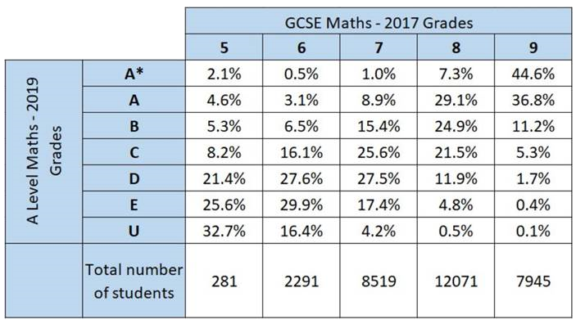

**About You**

**1. Full name:**

**2. Preferred name:**

*Phonetically spell it if at all unusua*l *(e.g. Dee-anna, Rum-pel-stilt-skin).*

**3. What other subjects are you taking?**

*I will assume they are A levels unless you state otherwise.*

**4. Intended subjects at university / future plans:**

*Any idea is better than nothing, even ‘something scientific’,*

*e.g. Maths at Oxford, Medicine, Chartered Accountant.*

*It may well change but knowing helps us to help you.*

**5. Why did you choose to study Maths A-Level?**

**6. Your own personal target grade in maths (A*-E):**

The table below shows typical grades achieved at A level for different grades achieved at GCSE. This may help you decide what is a realistic grade to aim for.

* Answer the questions below. Try to make your responses as thorough as possible.
* You do not have to share any information that you are uncomfortable with.
* The data you share in this questionnaire will not be shared with others without your permission (except in circumstances where safeguarding your wellbeing would take priority).

## **Start of the Year Questionnaire**

Instructions

**7. Are there any issues I should be aware of regarding you as a learner?**

*Examples include (but are not limited to):*

* *I cannot read the board from back of room.*
* *College bus makes me late.*
* *Fast during Ramadan.*
* *Do not contact parents because…*
* *Help care for family and often cannot work at home.*
* *Allergic to…*
* *Suffer from exam nerves (if unusually so).*
* *English is my second language – Urdu first but cope well with spoken English.*
* *Dyslexia (mild/severe).*
* *In the past I have struggled with… (punctuality, motivation, attention span, etc. )*

**Study Habits**

**8. Describe where you will work at home:**

*e.g. “plenty of space on desk in own room with a pc”*

*e.g. “lounge table but noisy environment”*

**9. When in the week do you plan to do your 5 hours of homework outside of lessons?**

*This may change throughout the year, but it helps to have an initial plan.*

*e.g. Tuesday P1, Thursday P3, Saturday 4-6pm.*

**10. What hobbies, sports, activities, part-time work do you take part in outside of college?**

*Try to specify roughly how much time they take.*

*e.g. 15 hours a week playing competitive online games such as PUBG.*

*e.g. 10 hours at weekends working in the family restaurant.*

**11. What computer facilities do you personally have?**

*e.g. I have a laptop at home with WiFi and unlimited data on my phone.*

*e.g. We have a shared computer at home which isn’t always available to me.*

**12. Please give any other information you think might be relevant.**